«Display_Name»

3D Animation Using Blender 2.7 - **Activity 3 (Cycles Version): Volumetric Clouds**

* Create a Cube, Click “Smooth” button. Squash it slightly to be shorter like an average cloud
* Change from “Blender Render” to “Cycles Render”
* Click **Material ** button. If three is a Material listed, click ‘-‘ to remove the Blender Render material.
* 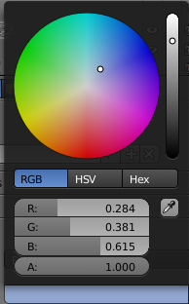New

Render Image to see what it looks like.

Make the cloud fuzzy:

* IN the Surface category, change Surface—click Diffuse, then click **Remove**.
* Then Expand “Volume” category, then change Volume from None to **Volume Scatter**
* Render again to see the fuzzy cube.
* Change background to a light blue: click World Button then change Color (see picture on right).
* File, Save As, 3dact3 clouds

**Making a cloud shape**

* Modifiers, Add Modifier, Subdivision Surface. Change both to 5 for accurate preview and render.
* 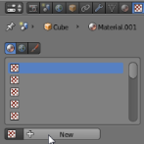Click **Texture**  button, New:
* Change Type to “Clouds” then select “Hard” option to get a marble-like cloud texture & you can change size so bumps are bigger (Size: about 1.0)

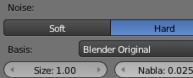 result: 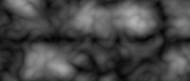

* Now change name from Texture to something like CloudDisplace so you can find it in a list box we will use later

* Click Modifiers  button, Add Modifier, then in the Deform Column Displace, & click checkerboard button to choose texture you named:

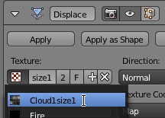

* + With any Displace modifier, it is good to set Strength so dark parts of Texture don’t push surface way in:

|  |  |
| --- | --- |
| Strength: 1.0 | Change Strength to 0.7 or whatever looks right |
| [If self-intersecting black shards still appear, a quick way to eliminate that is decimate modifier, Ratio about .1 or .01] | |

* Optionally apply the first (top) Subdivision Surface modifier & do proportional editing to improve the shape.
* Lighting will also help with realism. You can add a **yellowish-white** Sun (Add Lamp, Sun, click Sun object data button ) with high Energy (about 15) pointing straight down or at the sun’s angle.
* Add a **light blue** Sun with low Energy (about 8) pointing down to simulate the glow from the atmosphere.
* 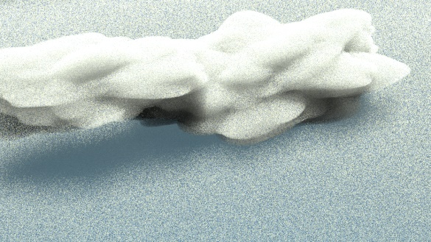For background, a gradient is more realistic, so under the World button choose Sky Texture.

If cloud glitches, the displacement may have made part of the cloud inside out. Make sure it is not too flat & that points are spread evenly. First make sure it is not too flat. Then Select a vertex in the middle of an area where vertices are spread apart & scale down to pull in the dense areas and make them less dense. (“Volumetric”)

You can put a large thin cloud underneath to create a quick cloudscape (see picture)